WATER EXPLORERS
Education Guide for Upper Primary & Middle Years
Ocean, River, Lake, and Coast Missions
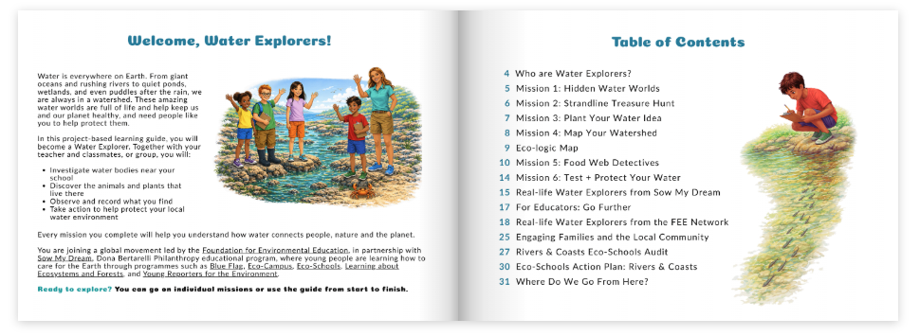

As you may know, in this year’s Lesson Plan Competition you are invited to explore the theme of Water Explorers and develop a lesson plan incorporating and testing activities from the new Water Explorers Education Guide, developed by FEE in collaboration with Sow my Dream, the educational programme of Dona Bertarelli Philanthropy.
This document provides teachers with guidelines on developing a lesson plan, and to make the competition fairer, as it allows to compare all submissions when using the same template. To improve your chances of winning the FEE Lesson Plan Competition, please include as many details as possible and bear in mind that your lesson plan needs to address one of the following pillars of sustainability and teach more than just cognitive knowledge:
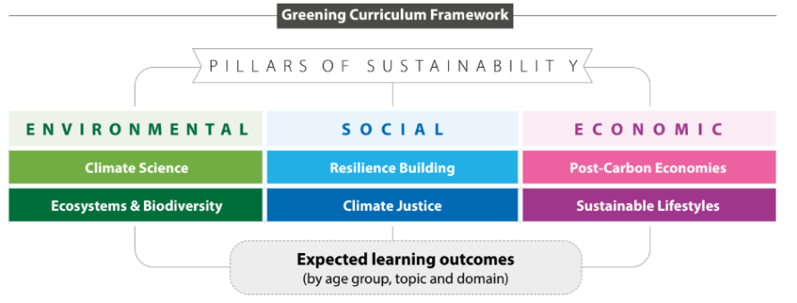
We thank you in advance for your participation and will do our best to share it with our network.
- Foundation for Environmental Education

- AUTHOR DETAILS
Name/s
Country
Institution/School
Email
Programmes the school is participating in (Eco-Schools/LEAF/YRE/other)
Submission date (dd/mm/yyyy)

- LESSON DETAILS
Lesson Title
Age Group
Time Required
Remote Preparation (if any)
Planning Considerations
Lesson tested in the classroom | O Yes O No
Which part of the Water Explorers Education Guide have you adapted or used to get inspired?

- THE LESSON PLAN

- Objectives or Learning Outcomes for the presented Lesson Plan – List 3-5 objectives/learning outcomes that you are expecting to achieve during the lesson.

Students are able to + [action verb] + [object/context].

- Objective: Numbers to be included in the lesson outline
- Objective:
- Objective:
- Objective:
- Objective:

- LESSON OUTLINE from the submitted lesson
This table is designed to help structure your lesson outline. As the educator, you decide how to adapt it, including the number of development phases (which includes the classroom activities) you include, and how you consolidate their outcomes. It is essential to link your numbered learning objectives to each step of the lesson, ensuring that every activity contributes directly to achieving the intended outcomes.
Lesson Phase | Learning Objectives  (O1, O2,O3, …) | Teacher Activity  e.g. poses a question “…”, arranges pupils into groups, … | Pupil/Student Activity  e.g. reads an article, filters information, writes down their own definition, … | Method/Social Form  Plenary discussion, Think–Pair–Share, Small group work, Guided questioning, etc. | Material needed  e.g. pptx, exercise sheet, poster, plants, ingredients | Didactic Intention (incl. pillars of sustainability + SDG competencies)  e.g. This activity is designed to create space for reflection on fairness and justice, linking global issues to students’ own lives.
Introduction
Lesson’s Objective / Hypothesis
Development Phase 1
Securing Learning (Phase 1)
Development Phase 2
Securing Learning (Phase 2)
Reflection on Hypothesis/ Revisiting Lesson’s Objectives
Transfer
Final Reflection & Outlook

- Material – Please add material (templates, cards, visuals) from the presented lesson here (if available)

- Evaluation and Assessment – How will you check that the Objectives or Learning Outcomes were achieved?

- Adaptations for stretch and challenges – if any gifted pupils/students with learning difficulties

- Background information for teachers - Include any website links and resources that would provide teachers with useful information about the lesson’s topic

- References – Acknowledge the resources that were used while developing the Lesson Plan.

